Work Instructions for Illumination Measurement
Objective:
- Illumination measurement

Scope: All over the plant.

Ref: Nil

- Aspect: Nil
- Impact: Nil
- Hazards: Physical- Falling.

Responsibility: Company Electrician , Enginner

- Illumination measurement shall be done by using Lux meter in the horizontal plain at a level of 90 cms above the floor level. Lux is a unit of illumination of one square meter, which is one meter away from a uniform light source.

- Lux meter used for illumination measurement shall be calibrated.

- When taking measurements, verify that occupants and objects /materials are not blocking any light to the meter head. Measurement points that are shaded, even partially, by obstructions that are not moveable should be noted for potential elimination.

- Identify the measurement locations by marking. It is important to measure the same locations for the baseline and post-installation lighting systems, or the same representative type of locations if fixtures are relocated for the retrofit.

- For each different set of lighting conditions, locate at least 6 measurement points. Record lux level at 6 different points & then take average.

- Refer below table for minimum lux level limit required for different places. If lux level measured is below required limit, then additional light fixture needs to be installed.

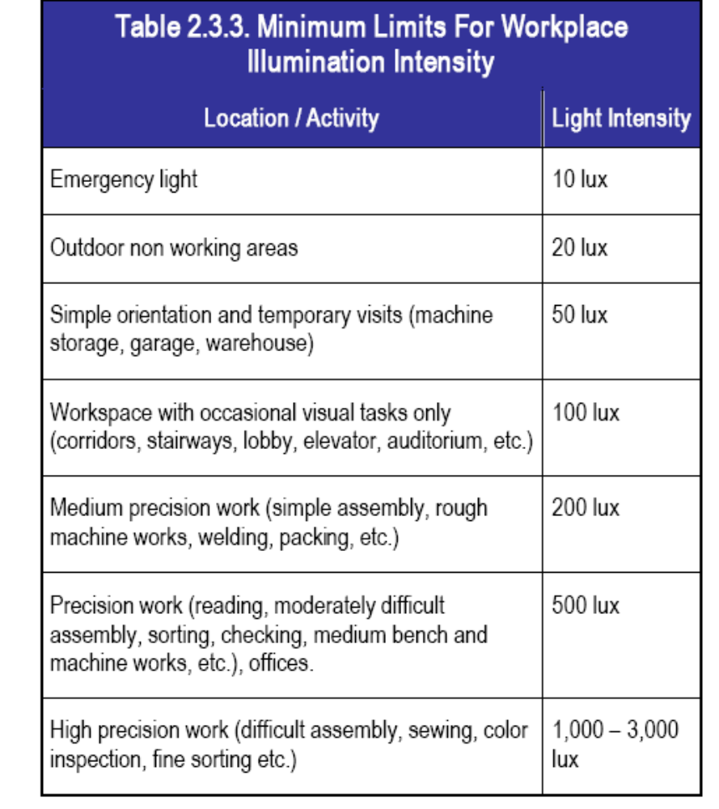

Amendement Record
Date | Manual Section Ref. & Para | Brief details of Revision | New Rev.

Prepared By:  Senior Elect. Engineer | Reviewed & Issued By:  Management Representative | Approved By:  Head – Electrical & Instrumentation PID I
Signature | Signature: | Signature:
Review Date: 04.03.2023 | Review Date: 04.03.2023 | Review Date: 04.03.2023

